ITRW 222

Class test 10/ Klastoets 10

Name:________________________ Number:________

Question 1 / Vraag 1

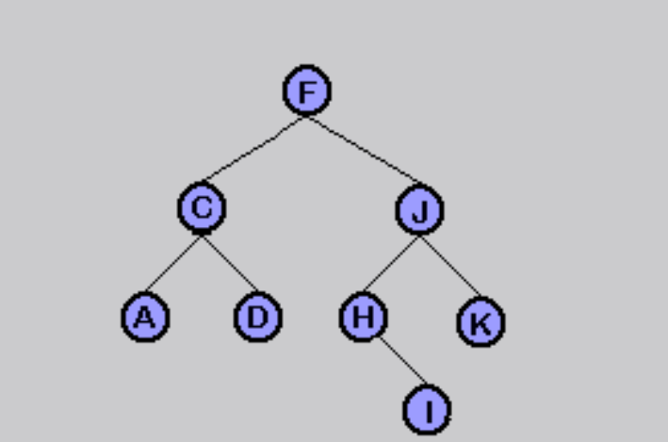

Gee die volgorde wat die volgende algoritmes deur die boom gaan beweeg:

Give the order in which the following algorithms will traverse the tree:

|  |  |
| --- | --- |
| Preorder: | FCADJHIK |
| Postorder: | ADCIHKJF. |
| Inorder: | ACDFHIJK. |
| Breadth first: | FCJADHKI |

**For an animated display of the order see:**

http://ceadserv1.nku.edu/longa/classes/mat385_resources/docs/traversal.htm